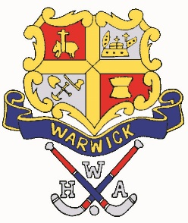
Warwick Hockey Association Inc.
C.C. Dunbar Clubhouse
Queens Park, Warwick
ABN: 47 421 594 484

PRESIDENT: Sheryl Windle PO Box 441, Warwick Qld 4370
SECRETARY: Susan Popple e: warwickhockeyqld@gmail.com
TREASURER: Mark Shadlow w: www.warwickhockeyassoc.org.au
2018 CONDAMINE VET’S SUPER 9’S - NOMINATION FORM

Association Name: |  | Shirt Colours:
Team Name: |  | Sock Colour:
Manager: |  | Umpire:
Manager Mobile: |  | Umpire Mobile:
Manager email:
[ ] Competitive [ ] Non-Competitive

TEAM LIST
NAME | DOB | NAME | DOB
1 |  | 8
2 |  | 9
3 |  | 10
4 |  | 11
5 |  | 12
6 |  | 13
7 |  | 14
Please note: WHA does not hold any insurance for individual players therefore players must endeavor to have their own insurance either through state nomination eg Hockey Qld or Hockey NSW or with another insurance agency or play at your own risk.
RULES OF COMPETITION
- Each team must provide an umpire.
- All male players must be 35 or over. All female players must be 30 or over.
- 2 ladies on field at all times.
- Penalty corners will be 3 on 3
- Penalty strokes replaced by shoot out
- All teams must have fully padded keepers
- Game times will be 15 or 20min halves depending on number of teams nominating

SOCIAL ACTIVITIES
Friday night – Entertainment, Bar & BBQ at the Warwick Hockey Clubhouse as well as 2 games of hockey.
Saturday night – Dinner at the Warwick Condamine Sports club Golf Course (cost at your own expense).
Please support the sponsors of this weekend and our association.

Please place the nomination fee of $100 in the WHA bank account: PLEASE USE A REFERENCE
Account Name: Warwick Hockey Association
Account Number: 400281250
BSB: 817001
Reference: Your team name

